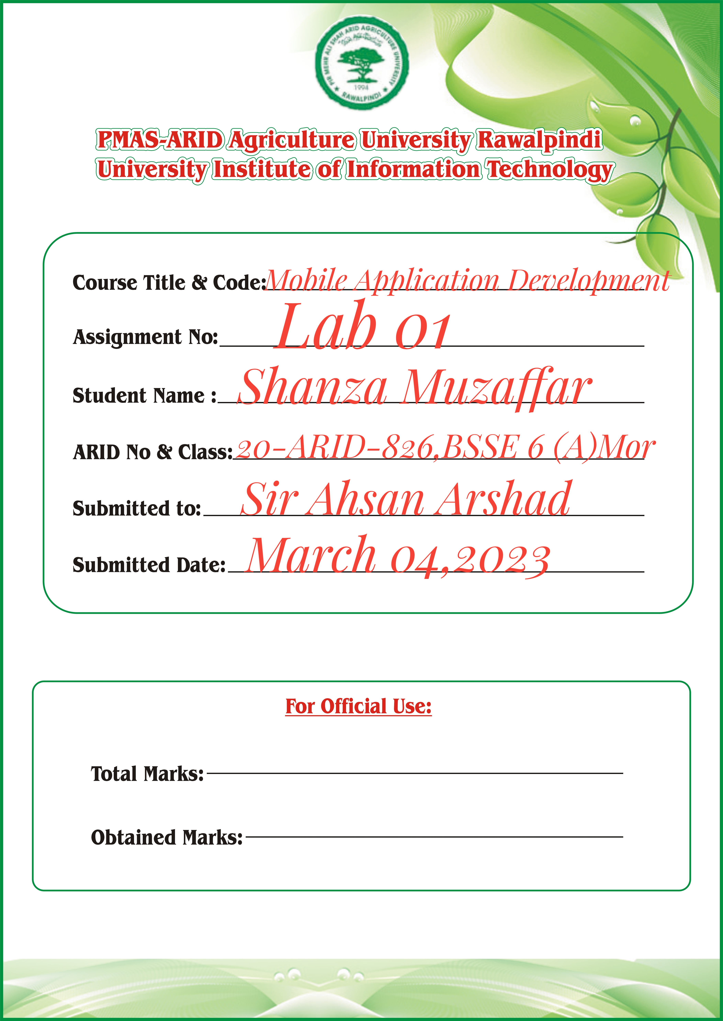

**ACTIVITY_MAIN.XML**

*<?***xml version="1.0" encoding="utf-8"***?>*<**LinearLayout xmlns:android="http://schemas.android.com/apk/res/android"  
 xmlns:tools="http://schemas.android.com/tools"  
 android:orientation="vertical"  
 android:layout_width="match_parent" android:layout_height="match_parent"**>  
  
 <**TextView  
 android:id="@+id/textView"  
 android:layout_width="match_parent"  
 android:layout_height="wrap_content"  
 android:layout_margin="30dp"  
 android:gravity="center"  
 android:text="Hello World!"  
 android:textSize="25sp"  
 android:textStyle="bold"** />  
  
 <**Button  
 android:id="@+id/button1"  
 android:layout_width="match_parent"  
 android:layout_height="wrap_content"  
 android:layout_margin="20dp"  
 android:gravity="center"  
 android:text="@string/change_font_size"  
 android:textSize="25sp"  
 tools:ignore="VisualLintButtonSize"** />  
 <**Button  
 android:id="@+id/button2"  
 android:layout_width="match_parent"  
 android:layout_height="wrap_content"  
 android:layout_margin="20dp"  
 android:gravity="center"  
 android:text="@string/change_color"  
 android:textSize="25sp"** />  
 <**Button  
 android:id="@+id/button3"  
 android:layout_width="match_parent"  
 android:layout_height="wrap_content"  
 android:layout_margin="20dp"  
 android:gravity="center"  
 android:text="Lab 2 task"  
 android:textSize="25sp"** />  
</**LinearLayout**>

**STYLE.XML**

*<?***xml version="1.0" encoding="utf-8"***?>*<**resources**>  
 <**style name="whiteText"**>  
 <**item name="android:textStyle"**>italic</**item**>  
 <**item name="android:textColor"**>#b38484</**item**>  
 </**style**>  
  
 <**style name="gfgGreenText"**>  
 <**item name="android:textStyle"**>bold</**item**>  
 <**item name="android:textColor"**>#391be0</**item**>  
 </**style**>  
   
</**resources**>

**MAIN ACTIVITY.JAVA**

**package** com.example.mylab;  
  
**import** androidx.appcompat.app.AppCompatActivity;  
  
**import** android.graphics.Color;  
**import** android.os.Bundle;  
**import** android.view.View;  
**import** android.widget.Button;  
**import** android.widget.TextView;  
  
**public class** MainActivity **extends** AppCompatActivity {  
 **int** ch=1;  
 **float** font=30;  
  
 @Override  
 **protected void** onCreate(Bundle savedInstanceState) {  
 **super**.onCreate(savedInstanceState);  
 setContentView(R.layout.activity_main);  
 **final** TextView t=(TextView)  
 findViewById(R.id.textView);  
 Button b1=(Button)  
 findViewById(R.id.button1);  
 b1.setOnClickListener(**new** View.OnClickListener() {  
 @Override  
 **public void** onClick(View view) {  
 t.setTextSize(font);  
 font=font+5;  
 **if**(font==50){  
 font=30;  
 }  
 }  
 });  
 Button b2=(Button)  
 findViewById(R.id.button2);  
 b2.setOnClickListener(**new** View.OnClickListener() {  
 @Override  
 **public void** onClick(View view) {  
 **switch**(ch){  
 **case** 1:  
 t.setTextColor(Color.RED);  
 **break**;  
 **case** 2:  
 t.setTextColor(Color.GREEN);  
 **break**;  
 **case** 3:  
 t.setTextColor(Color.BLUE);  
 **break**;  
 **case** 4:  
 t.setTextColor(Color.CYAN);  
 **break**;  
 **case** 5:  
 t.setTextColor(Color.YELLOW);  
 **break**;  
  
  
  
  
 }  
 ch++;  
 **if**(ch==6){  
 ch=1;  
 }  
 }  
 });  
 Button b3=(Button)  
 findViewById(R.id.button3);  
 b3.setOnClickListener(**new** View.OnClickListener() {  
 @Override  
 **public void** onClick(View view) {  
 **if**(ch==1){  
 t.setTextAppearance(R.style.whiteText);  
 ch++;  
 }  
  
 **else**{  
 t.setTextAppearance(R.style.gfgGreenText);  
 }  
 }  
 });  
 }  
}